

SESSION DE : JANVIER 2019 CENTRE : BORDEAUX

Langue anglaise 1 - CM
LMA1M113E1

Nature de l'épreuve : QCM (32 questions) | Durée de l'épreuve : 1 heure
Documents non autorisés

Questionnaire à réponses multiples

Répondez aux questions en cochant la ou les bonne(s) réponse(s) sur la grille de réponses fournie séparément.
Une seule grille de réponses vous sera délivrée. Veuillez donc bien prendre connaissance des instructions avant de la compléter.

Consignes de remplissage de la grille de réponses :

- Compléter vos coordonnées.  - Reporter votre numéro d’étudiant et cocher les cases correspondantes à votre numéro d’étudiant.  - Pour chacune des questions, vous devrez noircir (uniquement en noir ou en bleu) la case correspondante à votre réponse sur la première ligne.  - Pour corriger votre réponse, utilisez la deuxième ligne sans cocher « annul ». Seule cette deuxième ligne sera prise en compte au moment de la correction, quel que soit le marquage de la première ligne.  - Pour que la totalité de vos réponses de la 1ère et de la 2ème ligne soit annulée, cochez la case « Annul.» se trouvant sous le numéro de la question. Ceci équivaut à une absence complète de réponse. |  | 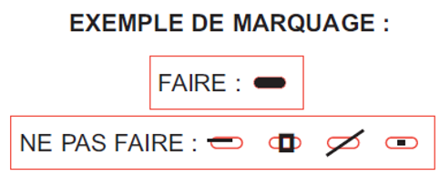  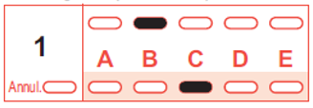  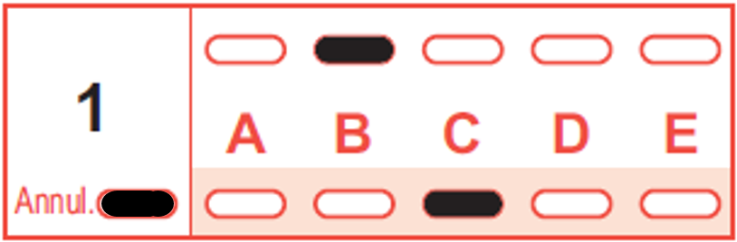 |  | 1ère ligne  2ème ligne  1ère ligne  2ème ligne
Le barème est le suivant :

Type de réponse | Nombre de points
Réponse juste | + 3
Réponse fausse | - 1
Absence de réponse | 0
Réponses incomplètes | Comprenant uniquement des réponses justes : nombre de points proportionnel au nombre de réponses justes.
Réponses incomplètes | Comprenant au moins une réponse fausse : nombre de point = 0

CULTURE AND ENVIRONMENTAL ISSUES

1. Which of these cities are shown to have connections with water quality issues?
a) London
b) Belfast
c) Edinburgh
d) Cardiff
e) Liverpool

2. Which of these cities are NOT located in England?
a) Manchester
b) Belfast
c) Edinburgh
d) Cardiff
e) Liverpool

3. Which of these cities boast a landmark whose name starts with the word “millenium”?
a) Manchester
b) London
c) Edinburgh
d) Cardiff
e) Belfast

4. Which of these cities are shown to have strong sea-faring and shipping histories?
a) Belfast
b) Manchester
c) Cardiff
d) Liverpool

5. Which of these environmental issues are NOT covered in the course?
a) Renewable energy
b) Air pollution
c) Coal-burning power plants
d) Drought

6. Which of the following landmarks are not located in England?
a) Tower Bridge
b) Arthur’s Seat
c) The River Mersey
d) Kensington Palace
e) Bute Park

7. Which of the following is a cathedral located in one of the six cities we visited?
a) Saint Patrick’s
b) Saint Arthur’s
c) Saint Paul’s
d) Saint Nazaire’s

8. Which of these cities did we NOT visit as part of the course?
a) Manchester
b) Newcastle
c) Edinburgh
d) Liverpool

ORAL COMPREHENSION

9.What has the green party been doing in London?
a)They have been demonstrating outside 10 Downing street
b) They’ve been installing monitoring tubes to measure air pollution
c) They’ve been organising a referendum
d) They’ve been selling face masks against air pollution

10. Which of the following statements applies to Lightsource’s facility in Northern Ireland?
a) It is a 35-acre solar panel farm
b) It will power all the households in the Belfast area
c) It is the most expensive failure in the history of renewable energy production

11. Which of these companies runs and operates the Glencorse water treatment facility?
a) Dŵr Cymru Welsh Water
b) Scottish Water
c) Thames Water
d) Yorkshire Water

12. Which of the following statement applies to Welsh farmer Alan Williams?
a) He started a class action lawsuit against the British Met Office because their weather forecast is often wrong
b) He set up 500 m² of solar panels on the roofs of his farm buildings
c) He set up a hydroelectric power system on his farm
d) He now breeds kangaroos instead of sheep and makes a lot more money

13. What can be said about the New Britain Oils company?
a) They run the largets palm oil farm in the UK
b) They claim they produce sustainable palm oil
c) They have launched a campaign against the use of palm oil in food
d) They claim their palm oil is traceable right back to their producers in Papua New Guinea

14. Which of these statements describes the palm oil industry?
a) The UK is the largest consummer in the world
b) India is the first country in the world to have banned the use of palm oil
c) It plays an essential part in protecting the environment
d) The largest producers are Indonesia and Malaysia

15. Which of these issues was discussed during the public consultation on Manchester’s Climate Change Strategy?
a) Windfarms
b) Solar power
c) Nuclear power plants
d) Fracking

WRITING

16. Which sentence(s) is/are correct about note taking?
a) Try to write down as much as you can of what you hear during a lecture, then take time to select important facts and data later.
b) It is useful to write down names, dates, figures, definitions, formulas, and quotes.
c) It is important to rephrase what you hear.

17. A paragraph is a succession of sentences on... :
a) ... a thesis statement.
b) ... a topic sentence.
c) ... a single topic.

18. Transition signals...
a) ... give unity to a text.
b) ... can introduce opposite ideas.
c) ... cannot introduce a restatement or an explanation.

19. In the UK, most urban areas have illegal levels of air pollution ....... ministers have lost three times in the high court after challenges over the inadequacy of their action. ......., the latest government action plan, called “pitiful” by environmental lawyers, revealed air pollution was actually much worse than previously feared.
a) however /As a result
b) whereas / So
c) and / Indeed

20. Semicolons are used...
a) ... before connectors. (ex: I have never been in Asia; in fact, I have never been outside the country.)
b) ... between items in a series, when some of the items already contain commas. (ex: Our guest speakers will be Dr. Richard McGrath, professor of economics; Dr. Beth Howells, professor of English; and Dr. John Kraft, professor of psychology.)
c) ... between two closely connected independent clauses. (ex: Andrew did not accept the job offer; he wants to go to graduate school.)

21. Which is the best sentence?
a) Sub-Saharan Africa is set to grow faster than anywhere: there were 1 billion Africans in 2010, but that number will grow to 2.5 billion by 2050.
b) Sub-Saharan Africa is set to grow faster than anywhere; there were 1 billion Africans in 2010 but that number will grow to 2.5 billion by 2050.
c) Sub-Saharan Africa is set to grow faster than anywhere: there were 1 billion Africans in 2010; but, that number will grow to 2.5 billion by 2050.

22. Which sentence(s) is/are correct?
a) A paragraph is always part of a longer piece of writing.
b) The length of a paragraph does not matter as long as it develops its main idea clearly.
c) A paragraph is not always indented.

23. Last week, Prime Minister Justin Trudeau announced that under the Greenhouse Gas Pollution Pricing Act, Canada will implement a revenue-neutral carbon tax starting in 2019.
What is the function of the commas in this sentence?
a) introducers
b) tag commas
c) coordinator

24. While violence and poverty have been cited as the reasons for the exodus of thousands of Central American migrants, experts say the big picture is that changing climate is forcing farmers off their land. This is an example of:
a) correct complex sentence.
b) correct compound-complex sentence.
c) comma splice sentence.

ENGLISH PRONUNCIATION

25. Choose the word or words which have a vowel sound that is represented by the symbol /ɪ/.
a) bean
b) bin
c) eat
d) it

26. Is the underlined consonant in the following word aspirated (voiceless) or voiced: “smog”
a) voiced
b) aspirated

27. Choose the word or words which have a vowel sound that is represented by the symbol /aɪ/ .
a) play
b) fine
c) home
d) feel

28. Choose the word or words which have a vowel sound that is represented by the symbol /ɔɪ/ .
a) new
b) law
c) joy
d) snow

29. Choose the word or words which have a vowel sound that is represented by the symbol /aʊə/ .
a) fur
b) power
c) liar
d) lower

30. Which one of the following words corresponds to this phonetic transcription: /ˈkʌltʃə/?
a) karaoke
b) called
c) culture
d) crushed

31. Choose the word or words which have a vowel sound that is represented by the symbol /ɔː/ .
a) low
b) saw
c) walk
d) work

32. Which of the following phonetic transcriptions is the correct one for the word “wanted”?
a) /wɒnt/
b) /wæntɪd/
c) /wɒntɪd/
d) /wɒnted/

